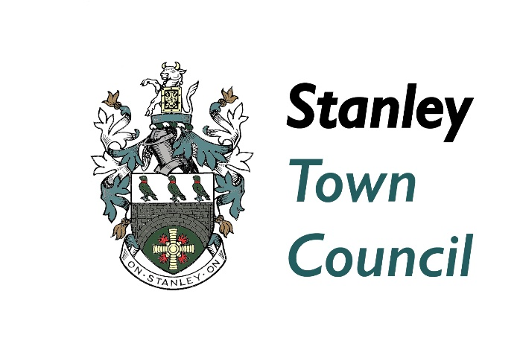

CHIEF OFFICER Stanley TOWN COUNCIL

JOB SUMMARY
Contract Type: Permanent
Working Pattern: Full time
Advert Published Date: 18 June 2024
Salary: LC SCALE 4 [£60,856 - £70,385 (scp50 to scp55)]
Job Category: Executive / Managerial
Employment Location: Stanley, County Durham, England
Number of posts: 1
Closing date: Closing date for Applications midnight 6th July 2024

FURTHER INFORMATION
Are you an energetic, politically astute, strategic thinker with a desire to bring about real improvements to the management and operations of the Town Council for the benefit of our local community? If so, Stanley Town Council are looking for someone like you to be their new Chief Officer.
Using your excellent management, policy development and financial skills you will ensure that the Town Council can deliver its strategic vision for the town and outlying villages This is a role which will both challenge and enrich your abilities with the backing of your fellow staff and Council members.

As the Chief Officer you will be the Proper Officer of the Council and will have a statutory duty to carry out the functions as required by law of a Local Authority’s Proper Officer. You will have full responsibility for ensuring that the instructions of the Council are carried out.
In the role you will be expected to advise the Council on, and assist in the formation of, overall policies to be followed and to produce all information required for making effective decisions and be accountable to the Council for the effective management of all its resources
You will work for one of the largest Town Councils in Durham at their office at The Greenhouse Business Centre, Amos Drive, Greencroft Industrial Park, Stanley with the option for hybrid working. On occasion you may be required to carry out duties across the area and at times which may be outside of core office hours dependent upon the tasks you are working on.
The Council will pro-actively support your continual professional development and if you do not already hold the Certificate in Local Council Administration you will be expected to study towards this within 12 months of taking up the post.
This is a fast paced and exciting role which will require someone of the highest quality to carry this out successfully. The Town Council has a vision which they need you to help refine and deliver for the people of Stanley.
If you have the right skills, knowledge, desire and enjoy the excitement of the challenge to develop and bring about sustainable change and improvements to the Town Council for the people of Stanley contact Ann Barry on 01207 299109 or e-mail Ann.Barry@Stanley-TC.gov.uk for a Candidate Information Pack.
If you wish to have an informal discussion around the role of Chief Officer, then please e-mail Jeanette Stephenson Leader of the Council at Jeanette.Stephenson@Stanley-tc.gov.uk to make a telephone appointment.

